Experiment no 6

**AIM:** To connect flutter UI by including with firebase database.

**THEORY:**

Firebase is a Backend-as-a-Service (BaaS) app development platform that provides hosted backend services such as a real-time database, cloud storage, authentication, crash reporting, machine learning, remote configuration, and hosting for your static files.

Since Flutter is a multi-platform SDK, each FlutterFire plugin is applicable for both Apple and Android platforms. So, if you add any FlutterFire plugin to your Flutter app, it will be used by both the Apple and Android versions of your Firebase app

**STEPS TO CONNECT FLUTTER WITH FIREBASE:**

1. Creating a New Flutter Project.

$ flutter create flutterfirebaseexample

$ cd flutterfirebaseexample

1. Creating a New Firebase Project.

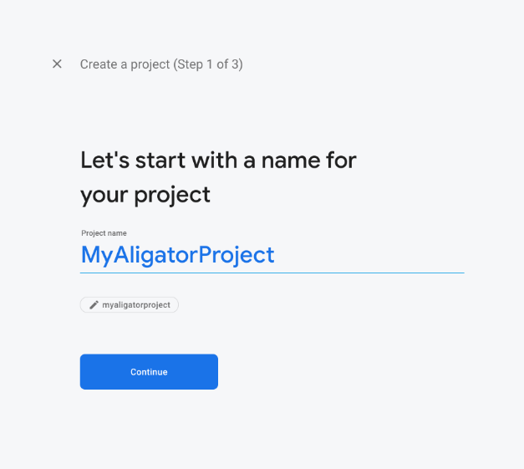

1. Adding Android support & Registering the App.

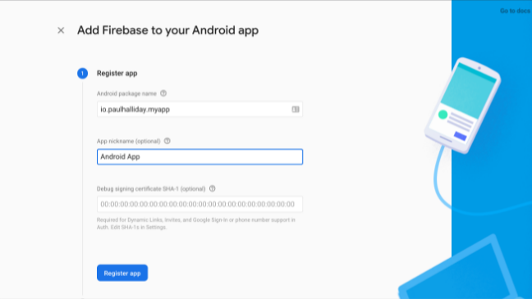

The most important thing here is to match up the **Android package name** that you choose here with the one inside of our application. Once you’ve decided on a name, open android/app/build.gradle in your code editor and update the applicationId to match the **Android package name**:

1. Downloading the Config File.

The next step is to add the Firebase configuration file into our Flutter project. This is important as it contains the API keys and other critical information for Firebase to use

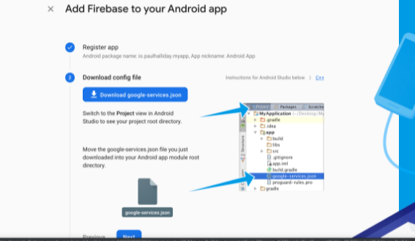

1. Adding the Firebase SDK.

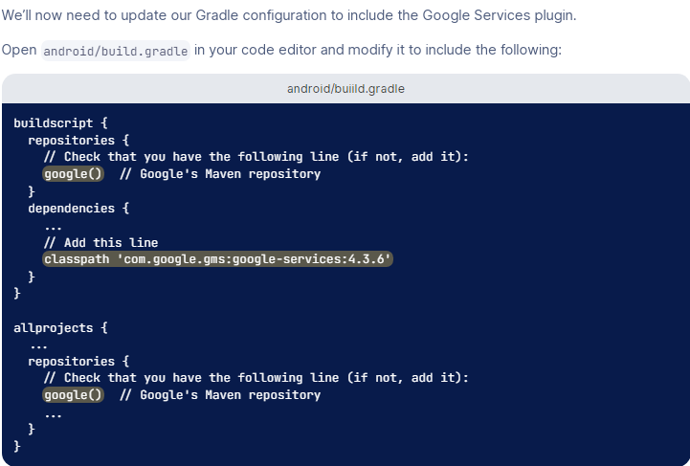

**CONCLUSION:** We have learned how to set up and ready our Flutter applications to be used with Firebase.